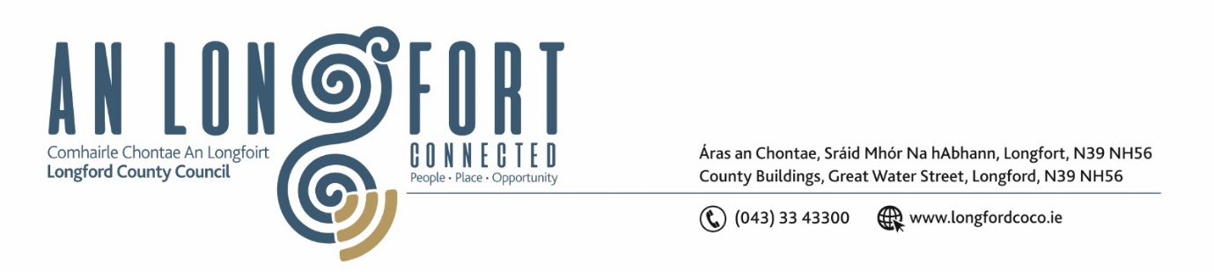

***LONGFORD MUNICIPAL DISTRICT***

***Please note meeting will be held via Microsoft Teams.***

**20th May 2021.**

**To: Each Member of Longford Municipal District.**

**Dear Member,**

You are requested to attend the Meeting of Longford Municipal District to be held

**via Microsoft Teams** on **Wednesday 26th May 2021 at 4.30pm** to transact business, as set out on the Agenda hereunder.

**Yours sincerely**,

Ann Marie Mc Keon

_______________

**Ann Marie Mc Keon**

**Meetings Administrator.**

**AGENDA**

Prayer before meeting.

**1.** Confirmation of Minutes of Longford Municipal District:

1. Meeting held on the 28th April 2021 – copy enclosed.
2. Committee Meeting held on 7th May 2021 – copy enclosed.

**2.** Matters arising from Minutes.

**3.** Declaration of Interest by Members.

**4.** Management Report - enclosed.

**5.** Regeneration of Camlin quarter update.

**6**. CCTV update – Presentation by Danny Lynch.

**7.** Consideration of Adoption of Part 8 No. 85 change of use from Healthcare facility to Residential dwelling at Newtownforbes, Co. Longford. Report in accordance with Section 179 of the Planning and Development Act 2000 (as amended) and Part 8 of the Planning and Development Regulations 2001 (as amended) – details enclosed.

**8.** Longford Back in Business (Parking Concessions).

**9. Notices of Motions, submitted by Councillors, as listed hereunder –**

**Councillor Martin Monaghan**

That Longford County Council look at putting a footpath/walkway between the Red Cow Roundabout & the Charlotte Brooke Roundabout even if we have to utilise the old road that exists.

**Councillor Martin Monaghan**

That Longford County Council write to the owners of the unfinished units situated in the Mastertech Business Park to secure these units properly as they currently pose a Health & safety risk.

**Councillor Martin Monaghan**

That houses that were previously connected to the Lough Forbes water treatment plant and have been switched to the Lanesboro treatment plant be put back to Lough Forbes treatment plant as soon as possible and that the works on Lough Forbes be expedited to solve the ongoing issues that have occurred with this switch.

**Councillor John Browne**

“In the interest of safety, I call on Longford County Council to have a speed ramp put in place opposite the children’s play area at Cartron Breac, Longford”.

**Councillor Gerry Hagan**

I call on Longford Municipal District to Serve a Dereliction notice order on the abandoned /derelict house at No 5 An Croissaire, Killoe in the interest of public safety.

**Councillor Gerry Hagan**

That Longford MD will carry out an evaluation on the traffic lights on Main Street, Longford at the junction at Richmond Street to facilitate more free flow of traffic through the junction and decrease delay time on traffic.

**Councillor Seamus Butler**

‘That Longford Municipal District review the terms and conditions regarding Michael Neary Park’

**Councillor Uruemu Adejinmi**

Inclusive public spaces allow for a healthy public life where social interactions can occur in all outdoor spaces and around public facilities. All our public spaces should seek to unite the entire community and support opportunities for individual well-being and promote equitable, healthy and committed communities.

I am therefore calling on Longford County Council to roll out wheelchair accessible picnic tables in public spaces in the Municipal District to make our public spaces in Longford more inclusive.

A sample of such picnic table is below and a member of the disability group in Longford is keen for this to be implemented and has put in an early request that the edges of the tables be curved and not sharp.

